Logbook

# Week 1 (09/10/2017 – 15/10/2017)

## Objectives

* Research existing film aggregation and review platforms

## Description

Throughout the course of this week I researched all of the existing platforms that implement some form of aggregation and/or review systems. I found the following to be the top platforms available today:

* [IMDb](http://www.imdb.com/)
* [Rotten Tomatoes](https://www.rottentomatoes.com/)
* [Netflix](https://www.netflix.com/browse)
* [Metacritic](http://www.metacritic.com/)
* [The Movie Database](https://www.themoviedb.org/?language=en)

IMDb unfortunately doesn’t have a proper API but instead allows users to download [subsets of data](http://www.imdb.com/interfaces/) such as the titles of movies for example. This will not be viable for my project.

Rotten Tomatoes does have an actual [API](https://developer.fandango.com/Rotten_Tomatoes), but limits the amount of information that developers are able to access/request from the API.

Finally, The Movie Database is a free [API](https://developers.themoviedb.org/3/movies/get-movie-details) service that allows users to request a variety of data on films and TV shows from, cast details, ratings, trailers, genres, etc. This is the service that I have decided to utilise for my project. There was one other alternative that was just as good as my selection, The Open Movie Database, however it was limited to 1,000 free daily request rate otherwise you had to become a patron and pay a monthly subscription.

## Problems encountered

Not really any specific problems encountered, other than it took longer than expected to finalise my decision on which API service to use. There also weren’t any open source options available that I could find and although this doesn’t affect my project directly it would’ve been nice to see how a service manages to aggregate all of the film data like The Movie Database does for example.

## Tools used

* Google Chrome

## References

* <https://developers.themoviedb.org/3/movies/get-movie-details>

## Keywords

API, request rate, patreon, open source

# Week 2 (16/10/2017 – 22/10/2017)

## Objectives

* Research and compare data mining techniques
* Select a suitable algorithm for this project

## Description

This week I looked into what data mining is and how I will use it for my project. I started off by researching the main data mining techniques and found that they were association, classification, clustering and prediction.

**Association:** This is where correlations between two or more data items are made, in order to identify patterns.

**Classification:** Is used to build up an idea of an object by describing multiple attributes that identify a particular class. For example, cars can be identified into different types (hatchback, coupe, 4x4) by identifying different attributes (number of seats, car shape, forward/rear/all-wheel drive).

**Clustering:** Is used to correlate and group attributes that have similar defining features.

**Prediction:** Often used in conjunction with one or more of the other data mining techniques, involves analysing trends, patter matching and relation in order to predict a value or class.

Prediction is definitely the technique that I will be utilising the most, feeding in all of the film data attributes such as genre, actors, directors, budget, etc and then predicting an overall rating based on this data.

## Problems encountered

Having already planned to build my application in Python, I hope that there is a data mining/machine learning Python library that I can incorporate into my project.

## Tools used

* Google Chrome

## References

* <https://www.kdnuggets.com/2015/05/top-10-data-mining-algorithms-explained.html>
* <https://www.ibm.com/developerworks/library/ba-data-mining-techniques/>
* <https://www.technologyreview.com/s/538701/data-mining-reveals-the-surprising-factors-behind-successful-movies/>

## Keywords

Data mining, association, classification, clustering, prediction, class

# Week 3 (23/10/2017 – 29/10/2017)

## Objectives

* Research database design
* Select an appropriate database management system

## Description

This week I looked into database design and how best to build the database that will house my training data. I started off by looking on Google to see if I could find any online schema designers and the best one I could find was [DbDesigner.net](https://dbdesigner.net/). This web application was extremely versatile and although it doesn’t allow non-premium users to save their designs it did allow me to save my SQL script and I even had the choice of PostgresSQL, SQLite, MySQL, MSSql or Oracle; which I was very impressed with.

Early on in the project planning phase, I new that I wanted to build an application that utilised a database in some way. I’ve had experience with MySQL in the past and decided that because of this reason and also because of the ease-of-use when it comes to linking a MySQL database to a front-end application of some sort that this would be the best database management system to implement.

Finally, I researched what the best visual database management system tool on the market was. I came across quite a few contenders such as HeidiSQL, dbForge Studio, DBTools Manager, etc but most of the options were not open source. I settled on MySQL Workbench which has a lot of documentation and is free to use. My favourite GUI database tool is by far Sequel Pro, but unfortunately is for MacOS only. So I will be using MySQL Workbench when working on my Windows PC at home and Sequel Pro whenever I am at university and am working on my MacBook Pro.

## Problems encountered

Sequel Pro only available on MacOS.

## Tools used

* Google Chrome
* MySQL
* MySQL Workbench
* Sequel Pro

## References

* <https://dbdesigner.net/>

## Keywords

Database, DBMS, MySQL

# Week 4 (30/10/2017 – 05/11/2017)

## Objectives

* Research similar projects for influence and references

## Description

This week involved a lot of research into existing projects that are similar in mine. This was something that I’d wanted to do for quite a while to see if anyone had undertaken a similar task, mainly to identify if they had run into any major issues and how I could overcome or avoid the same pitfalls altogether.

I managed to find a total of 5 very similar projects that would be an aid toward my project. The [first](https://nikhilwins.wordpress.com/2015/09/18/movie-recommendations-how-does-netflix-do-it-a-9-step-coding-intuitive-guide-into-collaborative-filtering/) talked a lot about film recommendations and how Netflix implements their suggestion algorithm, but also outlined how to build a collaborative filtering application in Python. The [second](https://nycdatascience.com/blog/student-works/machine-learning/movie-rating-prediction/) focused more on scraping films from IMDb instead of utilising an API like my project is going to and also was trying to answer the question *“Will the number of human faces in a movie poster correlate with the movie rating?”*. They focused on the IMDb film ratings but also pulled in other attributes such as an actor’s Facebook popularity. The [third](http://www.diva-portal.org/smash/get/diva2:352538/FULLTEXT01.pdf) project focused on answering the question *“How do movie producers identify the genre shifting trend?”*, so might not be as useful as previously thought. The [fourth](http://predictive.analyticsight.com/wp-content/uploads/2013/01/movie_genre_TimSchellhase.pdf) project focused on predicting the genre of a film by implementing a regression model. They analysed each film’s summary using topic clustering and then accurately predicted the genre of the film. Finally, the [fifth](http://usir.salford.ac.uk/18838/1/Wessex_movie.pdf) and most interesting project was a very similar project to mine and focused on the prediction of film ratings. They achieved this by selecting the data, cleaning and integrating it, transforming it and then finally performing the actual data mining. But instead of predicting a numeric value, they generalised the ratings into four categories: excellent, average, poor and terrible.

## Problems encountered

Only one project was very similar to mine, but I will be utilising slightly different data mining and machine learning techniques as well as displaying the data in a front-end application format.

## Tools used

* Google Chrome

## References

* <http://usir.salford.ac.uk/18838/1/Wessex_movie.pdf>
* <https://nikhilwins.wordpress.com/2015/09/18/movie-recommendations-how-does-netflix-do-it-a-9-step-coding-intuitive-guide-into-collaborative-filtering/>
* <https://nycdatascience.com/blog/student-works/machine-learning/movie-rating-prediction/>
* <http://predictive.analyticsight.com/wp-content/uploads/2013/01/movie_genre_TimSchellhase.pdf>
* <http://www.diva-portal.org/smash/get/diva2:352538/FULLTEXT01.pdf>

## Keywords

Regression model

# Week 5 (06/11/2017 – 12/11/2017)

## Objectives

* Research front-end frameworks
* Compare existing frameworks
* Select a suitable framework for this project

## Description

This week I focused on researching and selecting a suitable front-end framework for my project. Having decided early on to build my back-end in Python, I had to look for a front-end framework that would incorporate Python as the back-end. Django immediately came to mind, as I had heard of it a few times in the past and whilst on my placement. However, I had to ensure that I properly compared the existing frameworks to find the one that best suited my project and my experience with both Python and front-end web technologies.

I found a very good article which compared Django, Flask and Pyramid, three popular Python front-end frameworks. What I concluded from reading the article was that Django was the most popular framework, with the most StackOverflow questions relating to that framework having been asked, but was more suitable for mid-large applications. Pyramid is the most flexible, but can be intimidating for new users as it presents a lot of pre-configuration options that can be daunting. Flask however, is really useful for developers who are working on smaller projects and need a fast yet powerful Python front-end application. Flask also has the smallest footprint and requires a lot less code to perform the same task as the other frameworks. Django and Pyramid both have in-built tools for bootstrapping for example, meaning that it is very simple to setup a skeleton of the project quickly. They also support ORM (Object Relational Mapping) which makes it easier to connect to and manipulate a database from within Python code – instead of using basic SQL, tables are mapped to objects within Python. I discussed this with my supervisor and it was something that he hadn’t heard of himself, but in the end I decided that learning about and implementing ORM didn’t seem like an advantage.

Therefore, this is why I decided that Flask would be my framework of choice for this project.

## Problems encountered

Not knowing where to start with front-end Python frameworks.

## Tools used

* Google Chrome

## References

* <https://www.airpair.com/python/posts/django-flask-pyramid#1-introduction>

## Keywords

Framework, ORM

# Week 6 (13/11/2017 – 19/11/2017)

## Objectives

* Create an application architecture design diagram
* Design the database to hold the training data

## Description

This week I wanted to design and create an application architecture diagram, which will illustrate how my project will be setup.

I decided that I wanted to have my Python code that would retrieve the film data from the API, my database that would store all of the film data, an API which would retrieve the data from the database and my front-end website which would simply display the data. It is necessary for the front-end to ever only display data and to not request it directly from the database.

I designed a simple draft diagram in [Draw.io](https://www.draw.io/), having used the tool previously and allowing for the diagram to be saved directly to the cloud (Google Drive).

I started simple with my design and built the ***films*** table, that would house all of the film data, ensuring to specify which of the values would be my primary and foreign keys, what their types are, whether they should be unique values, whether they should auto increment or whether they should allow null values. For film data attributes such as ***genres****,* ***actors****,* ***production companies***it became apparent that I wouldn’t be able to store these directly in the ***films*** table, because a single film can have multiple iterations of these values. I solved this problem by storing these attributes in their own tables, but I then had to work on normalising the tables by adding in association tables between the ***films*** table and these newly created tables. For example, the ***genres***table stores the ***genre_id***and ***genre_title*** and is linked to the ***films*** table by an association table that stores the ***id****,* ***film_id***and **­*genre_id****.* I repeated these steps for the actors and production company tables.

## Problems encountered

Having never created an application architecture diagram, it took quite a bit of research before I was happy with the final work I had produced.

## Tools used

* Google Chrome
* [Draw.io](https://www.draw.io/)
* [DbDesigner.net](https://dbdesigner.net/)

## References

* <https://slidemodel.com/templates/software-diagrams-powerpoint/four-layers-modern-web-application-architecture-diagram/>

## Keywords

Application architecture diagram, primary/foreign keys, auto increment, normalisation, association table

# Week 7 (20/11/2017 – 26/11/2017)

## Objectives

* Create the database
* Think about storage/hosting options

## Description

This week I focused on actually building the database. I began by creating a simple Debian virtual machine with VirtualBox and installed MySQL. I created a simple database called ***training_data*** via the console in Debian and then worked on setting up MySQL Workbench to connect to my newly created database. Connecting to the database actually proved rather challenging, as I eventually found out that I had to ensure that the ***bind-address*** option within the config file (/etc/my.cnf) was set to my computer’s IP address. Once this had been resolved, I started on the actual table creation. Considering I already had my schema and SQL downloaded from DbDesigner.net, creating the tables was as simple as running the SQL in the query editor within MySQL Workbench. It however, didn’t work immediately, as a lot of the values were not correct and I found myself dropping and recreating the tables several times. I eventually managed to get all of the tables created, with the correct values and value types.

At this point I started to think about storage/hosting options, as having the database reside on a VM on my PC locally meant that I could not access and/or work on the database externally (i.e. at university). This would prove problematic in the coming weeks when I would be at university all week and during my free periods would want to work on my project. I decided that I would move the database to my Raspberry Pi (which first needed Raspbian to be reinstalled and MySQL to also be installed and configured) by exporting the ***training_data*** database. I then installed a service called ***XRDP*** which is a remote desktop service for Raspbian OS. This would allow me to remotely connect to it from (unfortunately) my local PC. This meant that I had to (using TeamViewer) remotely connect to my Windows PC at home, from my MacBook at university and then RDP from my Windows PC to the Raspberry Pi. This was a very long, tedious and expensive workflow process which I do not intend to keep indefinitely. I will continue to search for a better solution.

I do host my personal website with HostPresto and they allow me, with the package I have purchased, to setup two databases and two websites (with separate domain names). So, I might be able to host my entire application with my web hosting company. I will look into this in the next few weeks, or when I next have time.

## Problems encountered

Hosting the database on my Raspberry Pi proved to be a very expensive process.

## Tools used

* VirtualBox
* MySQL Workbench/Sequel Pro
* Raspberry Pi (Raspbian OS)
* XDRP

## References

* <http://www.circuitbasics.com/access-raspberry-pi-desktop-remote-connection/>

## Keywords

Virtual machine, Hosting, IP Address, RDP, SQL query

# Week 8 (27/11/2017 – 03/12/2017)

## Objectives

* Program the film data acquisition program (utilising TMDB API)

## Description

This week I began development on my Python film data acquisition code. I first had to set myself up an account with The Movie Database, which would then provide me with an API key. This was a very straight forward process. Next, I began simply attempting to retrieve data from TMDB using the Python [requests library](http://docs.python-requests.org/en/master/user/quickstart/). Using the film Inception as an example (grabbing the film ID from TMDB’s search tool) I managed to return film data in JSON format for this particular film, just like it shows in the API documentation.

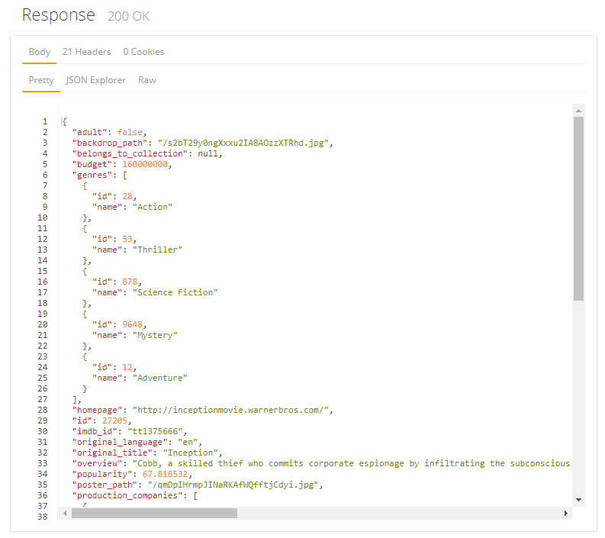

The documentation pages allow you to actually test requests in the browser to illustrate what you should see returned when performing this task externally.

I then managed to start working on and complete the function that takes the JSON file, locates the relevant film attributes, stores them in variables and then passes them to an SQL query called [***INSERT INTO***](https://www.w3schools.com/sql/sql_insert.asp), which takes a set of parameters and inserts them into an existing table. These parameters can even be Python variables as long as you pass them to the SQL query as [string formatters](https://www.tutorialspoint.com/python/python_strings.htm).

## Problems encountered

I did encounter one problem, where I was receiving a warning for every request made to TMDB API. I mitigated this issue by adding a disable warning piece of code:

* requests.packages.urllib3.disable_warnings()

This, according to a StackOverflow post, was not an error and was perfectly fine to disable.

## Tools used

* [TMDB API](https://developers.themoviedb.org/3/getting-started/introduction)
* [Python 2.7](https://www.python.org/download/releases/2.7/)
* [Jetbrains PyCharm](https://www.jetbrains.com/pycharm/)

## References

* <https://developers.themoviedb.org/3/getting-started/introduction>
* <https://www.themoviedb.org/talk/5406a1670e0a261889000376?language=en>
* <https://www.themoviedb.org/talk/54f41aafc3a3683455000991?language=en>
* <http://docs.python-requests.org/en/master/user/quickstart/>
* <https://www.themoviedb.org/movie/27205-inception>
* <https://www.w3schools.com/sql/sql_insert.asp>
* <https://www.tutorialspoint.com/python/python_strings.htm>
* <https://stackoverflow.com/questions/42839363/python-disable-warnings-for-securitywarning-certificate-has-no-subjectaltnam>

## Keywords

Python, JSON, INSERT INTO

# Week 9 (04/12/2017 – 10/12/2017)

## Objectives

* Continue building the Python application

## Description

This week I continued with my Python development. I found two very useful forum posts, where a couple of TMDB users had asked how to retrieve all film data. The simple answer was to iterate over the API, which I had already concluded. So, I began to build out the functions that I would need:

* insertData()
* matchGenres()
* matchProdComps()
* matchActors()
* insertFilms()

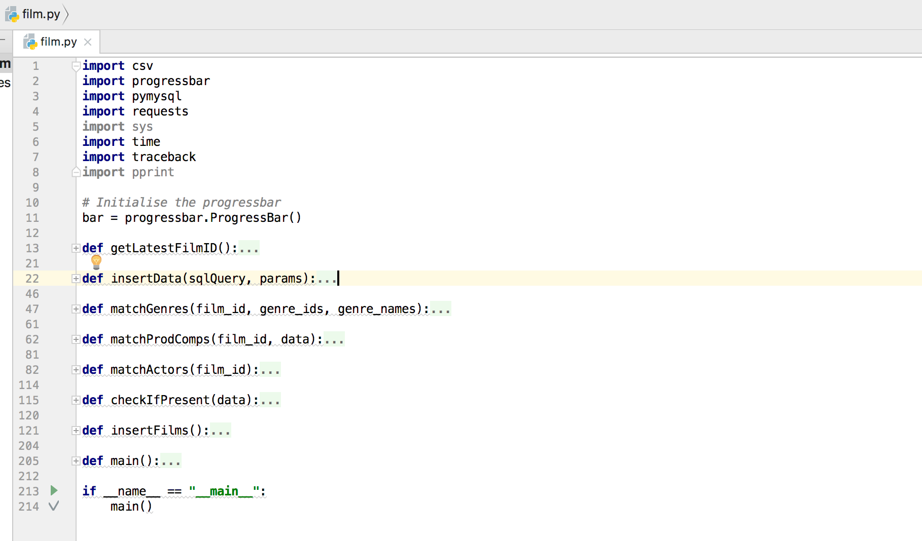

## Problems encountered

## Tools used

* [TMDB API](https://developers.themoviedb.org/3/getting-started/introduction)
* [Python 2.7](https://www.python.org/download/releases/2.7/)
* [Jetbrains PyCharm](https://www.jetbrains.com/pycharm/)

## References

* <https://developers.themoviedb.org/3/getting-started/introduction>
* <https://www.themoviedb.org/talk/5406a1670e0a261889000376?language=en>
* <https://www.themoviedb.org/talk/54f41aafc3a3683455000991?language=en>
* <https://www.themoviedb.org/movie/27205-inception>

## Keywords

N/A

# Week 10 (11/12/2017 – 17/12/2017)

## Objectives

* Continue with Python development
* Design a questionnaire to gather statistics about the most important film attributes

## Description

This week I focused on making the main function iterable via a local variable (***latest_film_id***) which is a variable returned from the ***getLatestFilmID()*** function and that function jut queries TMDB API which has a ***GET /movie/latest*** URL.

I also implemented a [progressbar](https://pypi.python.org/pypi/progressbar2), utilising the Python library which would (using the latest film id as a maximum value) display a progressbar in the console so that I could identify the percentage of completion when my application was executing. This would be extremely useful when it came to running my final execution.

This week I also managed to design and create a questionnaire using Microsoft Forms. I thought the questionnaire would be a good way to gather statistics on people who watch films, whilst at the same time allow me to determine how people who watch films rank the film attributes regarding how much of an effect said attribute has on whether they see a film. The questionnaire ended up having a total of 4 questions:

* Please specify your age
  + Dropdown box with a ‘Prefer not to say’ option.
* How many films do you watch on average, per month?
  + Radio buttons.
* Which platform(s) do you use to watch films? (Select all that apply)
  + Multi-select radio buttons.
* Please rank the following attributes, indicating which hold the highest weight for you when deciding whether to watch a film
  + List of film attributes that can be ordered by dragging and dropping into place.

## Problems encountered

* <https://developers.themoviedb.org/3/getting-started/introduction>
* <https://www.themoviedb.org/talk/5406a1670e0a261889000376?language=en>
* <https://www.themoviedb.org/talk/54f41aafc3a3683455000991?language=en>
* <https://www.themoviedb.org/movie/27205-inception>
* <https://pypi.python.org/pypi/progressbar2>

## Tools used

* [TMDB API](https://developers.themoviedb.org/3/getting-started/introduction)
* [Python 2.7](https://www.python.org/download/releases/2.7/)
* [Jetbrains PyCharm](https://www.jetbrains.com/pycharm/)
* [Microsoft Forms](https://forms.office.com/Pages/DesignPage.aspx#FormId=xDv6T_zswEiQgPXkP_kOX7zAW1OgPQRFlgBCrgMdZ1BUN0pRQzlLQzlHTlpGWjNUS0JTMlFLM1pYMi4u)

## References

* N/A

## Keywords

N/A

# Week 11 (18/12/2017 – 24/12/2017)

## Objectives

* Consider implementing the YouTube API to gather trailer statistics
* Research if an API exists to gather information on Oscar winnings

## Description

This week I worked on gathering data on trailers as per a suggestion from my supervisor. I started by researching the YouTube API, reading the documentation and see how simple it would be to gather the data I required with just the video id that I had acquired from querying TMDB API.

After some research, I found that I was after the ***Videos: list*** section of the YouTube API. Running the in-built browser request tool, I found that I would need to locate the specific JSON object, ***items[statistics]***.

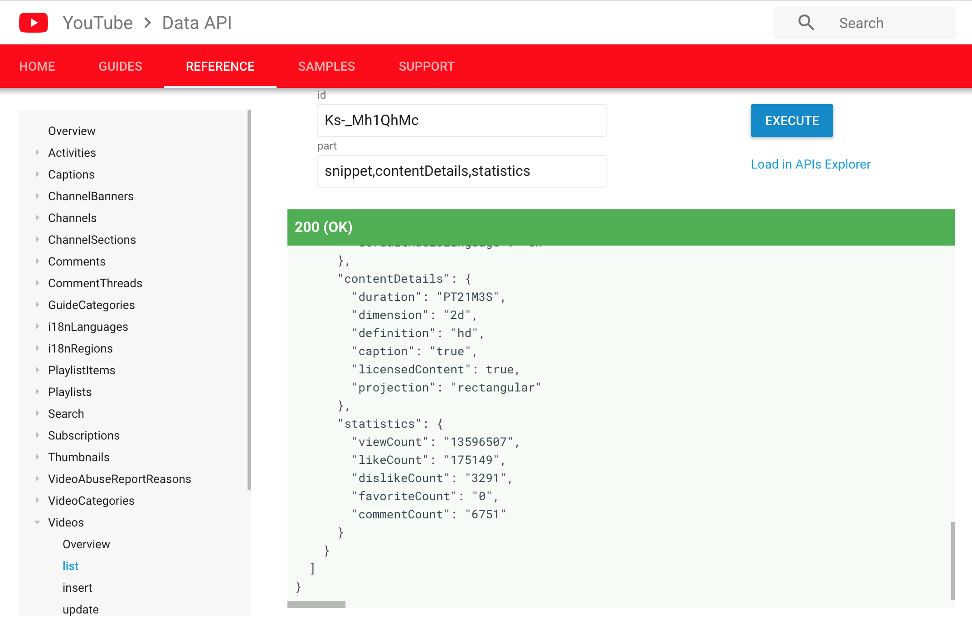

This would provide me with all of the video data that I was after – total view count and like/dislike count.

Implementing this function in Python was a lot simpler than expected, I called it ***getTrailerViewCount()*** and simply had to use the same responses library that I used to gather the film data from TMDB API. I did however, also require a key via the YouTube API service for developers. Using the Google APIs Developer dashboard, I created an API key without any restrictions for now and assigned it the access to the YouTube API service.

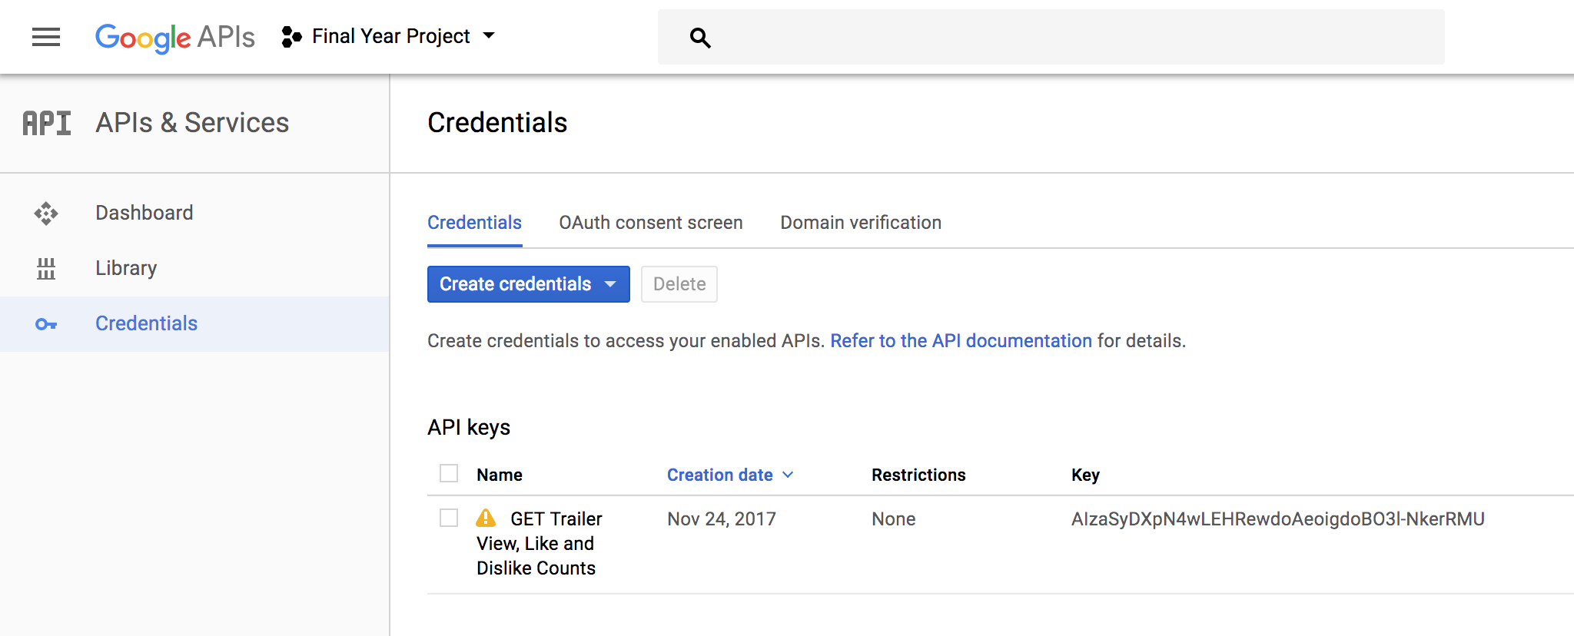

From here, I now had access to the YouTube API service my API key and a simple test in the browser demonstrated this.

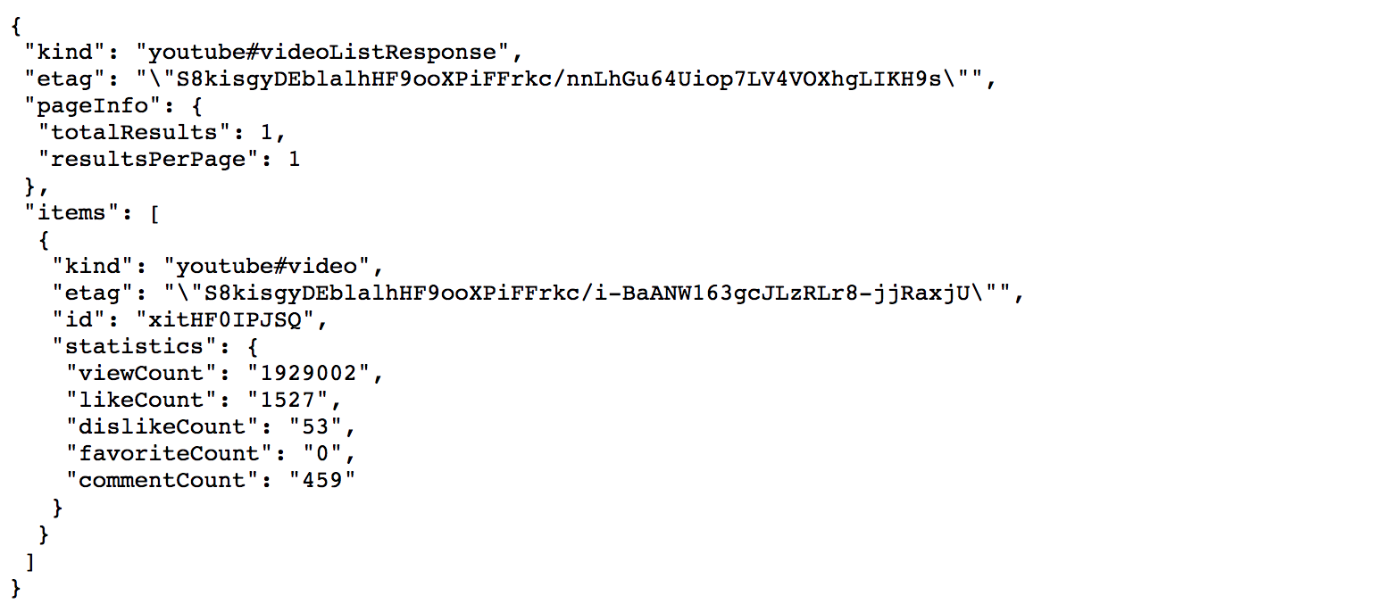

Which returned the JSON without any issues.

From here I was able to build up a simple function that traversed the JSON, stored the required statistic values into variables and then passed these variables to the main function that would later insert the values into the database; ensuring to return null for any values that were not present in the JSON object.

I also ended up uploading my populated database to my web hosting company, after first having created a new database via the [CPanel](https://cpanel.com/) dashboard that HostPresto provide access to. I also had to allow remote connection to the MySQL server, which is carried out by adding access hosts (my device IP addresses) to the ***Remote MySQL*** section of the dashboard.

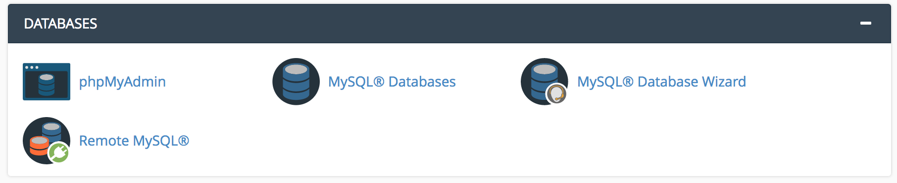

Then, under the software tab I decided to see how difficult it would be to setup a Flask application with my web hosting as well. CPanel actually provides a lot of simple and straightforward tools for setting up a Python application. I simply had to go to the ***Setup Python App*** section of the dashboard, select the Python version I would be using, the application directory, the domain (which I set as my personal domain for now) and then any additional modules that I would require. I just installed the main ***Flask*** module.

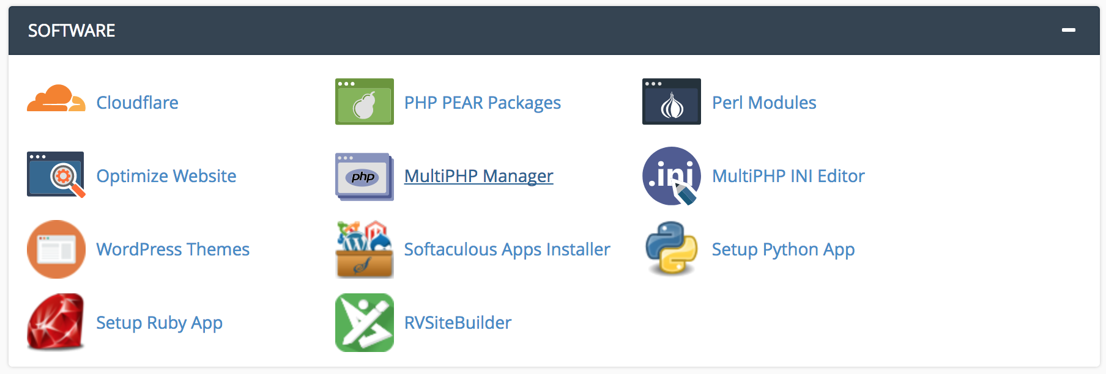

It was then accessible via the app URI, which is just my personal domain followed by the app directory (filmpy).

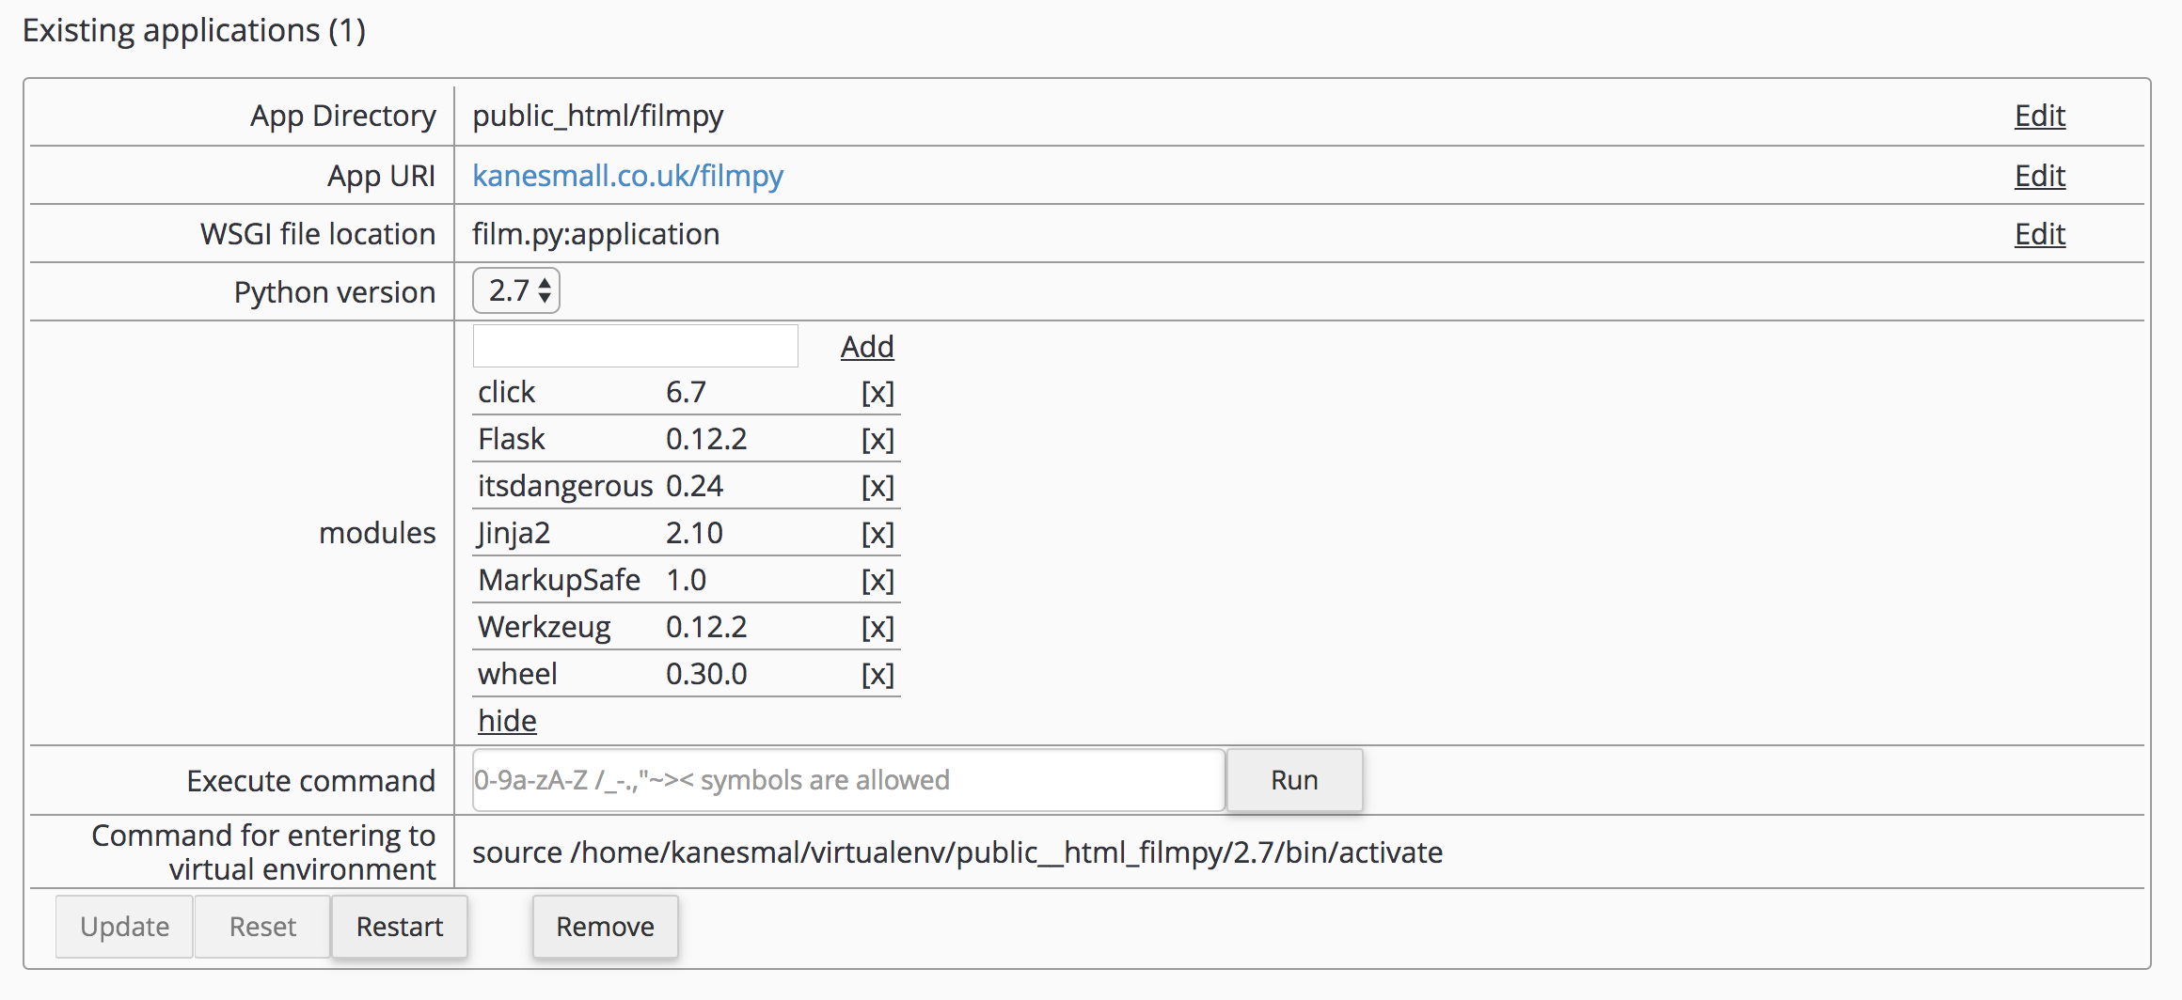

I also made sure to limit the number of hosts that could access the MySQL database remotely, by specifying the access hosts explicitly.

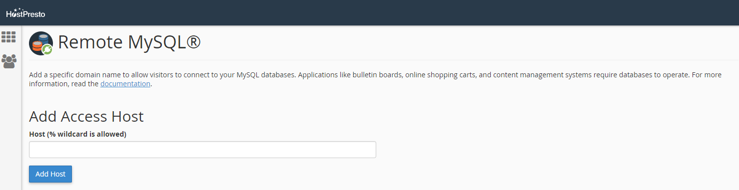

## Problems encountered

I had a problem with the YouTube statistics gathering when traversing the JSON that was returned from YouTube’s API. This ended up being a problem with the way in which I was looking for specific data within the JSON returned from the YouTube API. It was erroring because I was asking for it to return data that didn’t exist, i.e. when a YouTube video has likes/dislikes disabled or is no longer available. To mitigate these issues, I just performed simple if statement checks around these JSON search queries that would check first if the JSON object existed and the second, if the object was null. I later moved this to a separate function (***checkIfPresent()***) as I found that I was having to perform this check regularly throughout the application.

## Tools used

* CPanel
* Google Chrome

## References

* <https://developers.google.com/youtube/v3/docs/videos#resource>
* <https://opendata.stackexchange.com/questions/3668/is-there-an-api-for-the-oscars-academy-awards-that-lists-past-winners-as-well-as>
* <https://cpanel.com/>
* <http://calderonroberto.com/blog/how-to-deploy-a-flask-python-app-for-cheap/>

## Keywords

CPanel, Access Host, % Wildcard

# Week 13 (01/01/2018 – 07/01/2018)

## Objectives

* Develop SQL queries to transform the downloaded film data

## Description

This week I have been working on developing the queries to transform the data. This involves taking film attributes such as ***genre****,* ***actors****,* ***production companies***, etc and calculating a numerical value for them. However, it will be useful to take the answers from the questionnaire as an indicator as to the most important attributes (subjectively) that incorporate a film’s success.

I started by thinking about the way in which I wanted to provide these values with a numerical rating. I decided that the best way would be to take every film that had a specific genre for example and to average those ratings in order to provide each individual genre with its own rating.

Firstly, I tried to calculate these values by an ***INNER JOIN*** on the ***films*** and ***film_genres*** tables, but found that this was not giving me the correct results. So, I changed the query to join three tables together, the ***films****,* ***film_genres*** *and* ***genres***tables. This would also allow me to take the actor’s name and use it in the output. I ended up matching the ***films*** and ***film_genres*** tables via the ***film_id*** value that was present in both tables and then for the ***genres*** and ***film_genres*** tables via the ***genre_id*** value that was present in both tables. This logic was basically saying that, for a genre with x id, return the results of where it is present in both the ***films*** and ***film_genres***tables and then the same logic applied to the other join. I finally used a ***WHERE*** clause, which only returns the data from the tables where the ***film_vote_count*** value (how many people have actually voted) is above 999. This would hopefully eliminate any potential outliers, such as with actors who have only been in two small and potentially unheard-of films that have both received a 10/10 rating. Subjectively, these actors should not receive an individual rating of 10.

## Problems encountered

My initial calculations suggested that running the query I had written would take 2hrs 50mins given how large my dataset is. But this did not end up being the case. I am however, still unsure as to whether the results it produced are accurate.

I also had a few issues with the number of requests my application was making to the YouTube API service. I found a post on [StackOverflow](https://stackoverflow.com/questions/15568405/youtube-api-limitations) that detailed the exact number of requests that users were allowed to make (the quota), but after checking my API dashboard I was not going over this limit. In the end, the only way to mitigate the issue was to recreate the API and to use the new API key.

At the end of last week, I also executed the program for the first time on the Raspberry Pi.



## Tools used

* MySQL Workbench

## References

* <http://usir.salford.ac.uk/18838/1/Wessex_movie.pdf>
* <https://stackoverflow.com/questions/15568405/youtube-api-limitations>

## Keywords

INNER JOIN, WHERE

# Week 15 (15/01/2018 – 21/01/2018)

## Objectives

* Acquire director data for each film (limit to top 10)
* Reacquire actor data for each film (limit to top 10)

## Description

This week I focused primarily on the acquisition of director metadata for each film as well as the reacquisition of actor data for each film, but this time limiting the maximum number of actors acquired to simply the top 10. This is mainly due to these often being the most important actors/actresses of the film and acquiring anymore would simply require a lot more storage and could potentially skew the regression algorithm results/accuracy.

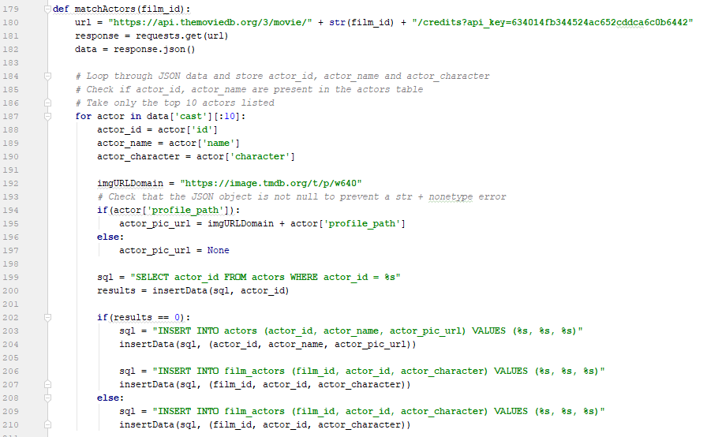

## Problems encountered

I realised that I had forgotten to retrieve details for the directors for each film. This was most likely an omission due to the fact that each film can have multiple directors and would therefore also require a separate ***directors*** table, joined to the ***films*** table by an association table (***film_directors***). I also have decided that (even though I previously had concluded that this would not be a problem) acquiring all actors that appeared in a film is unnecessary and will be expensive for any future calculations. I will therefore re-run this specific section (acquisition of actors) at the same time as grabbing the directors. Because of the way in which I built my application, it is quite modular and will be able to run and only retrieve these values. My supervisor suggested that it would be a good idea to justify the reasoning behind limiting actors top 10.

## Tools used

* PyCharm
* MySQL Workbench

## References

* N/A

## Keywords

N/A

# Week 17 (29/01/2018 – 04/02/2018)

## Objectives

* Start considering how to build API routes
* Fix actor/director data acquisition

## Description

This week I focused on researching how to build API routes within Flask. This had me primarily looking at how to utilise POST and/or GET parameters within the Flask framework and how to use the various route registrations to allow either variables to be passed through the API route or queries.

From my research it seems as though, variable sections of a route URL are defined using angular brackets like so: **/films/<film_id>** and by default accepts a string. However, I needed to accept an integer value in this position, so in order to do just that I need to use a different *converter* like so: **/films/<int: film_id>**.

My script that was running on the raspberry pi also happened to be killed without any proper indication as to why. So this required fixing (more information can be found in the *problems* section).

## Problems encountered

Toward the end of the actor/director data acquisition, the program froze and then was killed what I can only presume was due to the program being inactive for such a long period of time or due to a lack of memory that the raspberry pi has. I managed to restart it and alter the code to only collect the data for the remaining film_id’s.

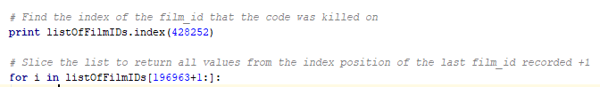

This was mitigated using Python’s list slice functionality.

There are also quite a few errors in the csv file, ~313 all of which errored for various reasons one of the main one being that my host could not connect to my database which is hosted with my web host provider. To resolve this issue, once I’ve completed more of the front end I will update the program and create a function that continuously monitors and updates each film’s data, retrieving any missing data automatically.

## Tools used

* PyCharm
* MySQL Workbench

## References

* <http://blog.luisrei.com/articles/flaskrest.html>
* <http://flask.pocoo.org/docs/0.12/api/#url-route-registrations>

## Keywords

N/A

# Week 18 (05/02/2018 – 11/02/2018)

## Objectives

* Build up the API routes.
* Create classes to hold the film data in Python.

## Description

This week was an extremely busy week as it was focused on creating the API routes that would interface with the front-end of the application.

Each route essentially required the creation of a class that would store all of the relevant data in the correct format. So for example, for the **/film/<int:film_id>** route, each film that was searched by it’s id would need to return all of the following information:

* film_id
* film_title
* film_tagline
* film_overview
* film_poster_url
* film_release_date
* film_budget
* film_revenue
* film_runtime
* film_status
* film_vote_average
* film_prediction_rating
* film_vote_count
* film_trailer_url
* film_trailer_view_count
* film_trailer_like_count
* film_trailer_dislike_count
* genres
* actors
* production_companies
* directors

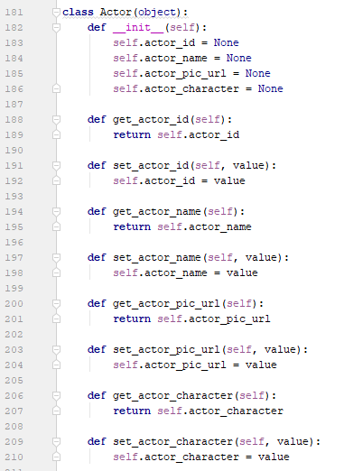This data also had to be converted into a JSON-format so that the front-end would be able to actually read the data.

Each class was created similar to the example above, where the variables were defined and then the setters and getters were initiated.

## Problems encountered

The biggest problem encountered was converting my complex Python classes into a JSON format. I continually received the error “Object is not JSON serializable”, which took me a very long time to decipher. Eventually I was directed to a Python library called ‘jsonpickle’ which essentially translates complex Python classes to JSON objects.

## Tools used

* PyCharm
* MySQL Workbench
* Google Chrome

## References

* <https://stackoverflow.com/questions/2627002/whats-the-pythonic-way-to-use-getters-and-setters>
* <https://www.w3schools.com/sql/sql_like.asp>
* <http://blog.luisrei.com/articles/flaskrest.html>
* <https://jsonpickle.github.io/>

## Keywords

Class, API, Routing

# Week 19 (12/02/2018 – 18/02/2018)

## Objectives

* Finalise demo for Tuesday.
* Make a proper start on the prediction algorithm and training the classifier.

## Description

During my preliminary demo with my supervisor this week, I showcased what I currently had and then we talked about where I could take it from here. We decided that it would be a good idea to have other film data analytics such as which genre has the highest number of well-rated films, or which genre has the highest average revenue, etc. I also suggested that I have an about page that details (at a very low level) how my application functions and how the prediction algorithm will work. I would also like to have a piece of text that will update dynamically, letting the users know that the system (API) has last been updated 2 minutes ago for example. Finally, we discussed the possibility of pulling in additional ratings, i.e. from Rotten Tomatoes and Metacritic.

We also talked about the report and how best to structure it. Primarily to ensure that I have a table of figures after the table of contents, a glossary, an individual reflection, etc. I also decided that I would start using git version control (GitHub), so that I could write up about the many benefits of using a system like that.

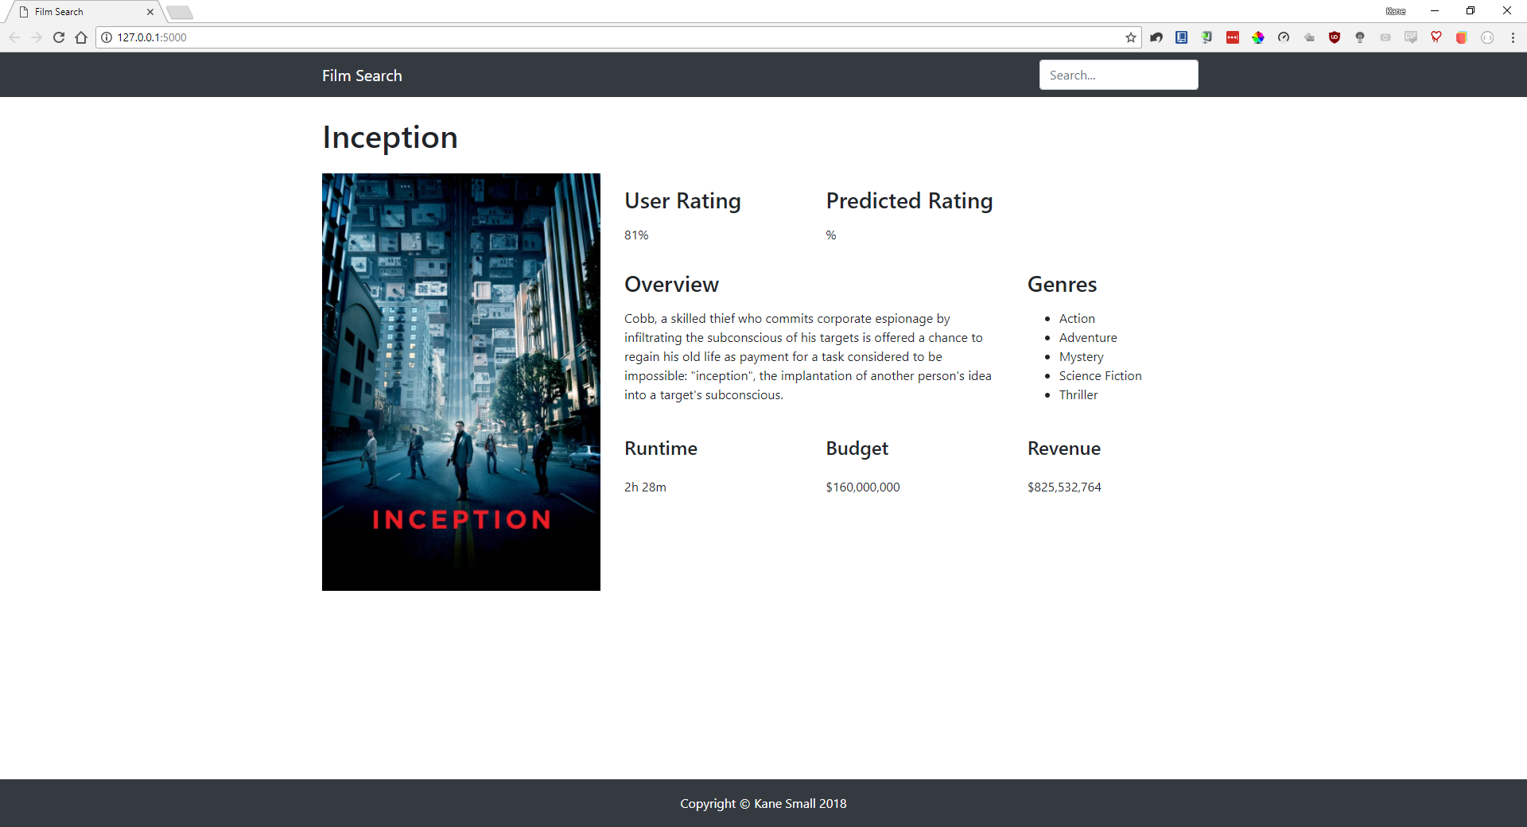

## Problems encountered

* Certain films in my database have stored data that should not be null.
* Need to loop over genres, actors, directors and production companies and update/populate the webpage accordingly for each search.
* Every poster path URL in my database (per film) is incorrect and this part ***w640*** needs replacing with ***w1280***. The same goes for the actor pic URL and director pic URL.
* I also decided that I would like the backdrop image for each film, so in my update function I will request this additional field.

## Tools used

* PyCharm
* MySQL Workbench
* Google Chrome
* GitHub

## References

* <https://github.com/kanesmall/final_year_project>
* <https://www.atlassian.com/git/tutorials/what-is-git>

## Keywords

Version control, repo, commit, merge, branch, master, clone

# Week 20 (19/02/2018 – 25/02/2018)

## Objectives

* Remove films from the database with the film_status ‘cancelled’

## Description

I had discussed with my supervisor that it would be a good idea to remove all films that had the film_status ‘cancelled’, as these films would not be useful for the training or testing phases of the regression algorithm.

First, I had to check the number of distinct film_status values that there were and carried this task out by using the following SQL:

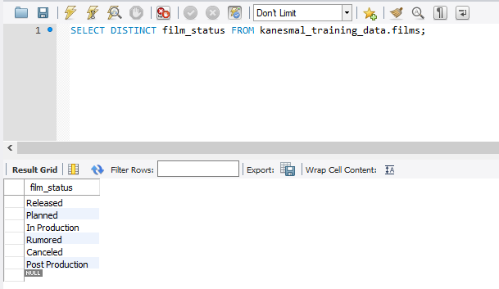

Initially I attempted to delete the films that had the specific film_status (cancelled), but before realising that I would also need to delete the referenced tables that had foreign key links to the films table I executed the statement. Luckily, MySQL Workbench prevents the user from deleting any content that is referenced in another table. To mitigate this issue, I essentially utilised the ‘CASCADE DELETE’ option which deletes all of the data from the specified table as well as any referenced table data.

In order to utilise this function though, the existing tables had to be altered to allow this operation to be performed on foreign keys. To do so I simply navigated to **alter table > foreign keys > foreign key options > on delete** and changed this value to ‘CASCADE’. Now by running the following SQL statement, I can ensure that all of the tables that have referenced data appear:

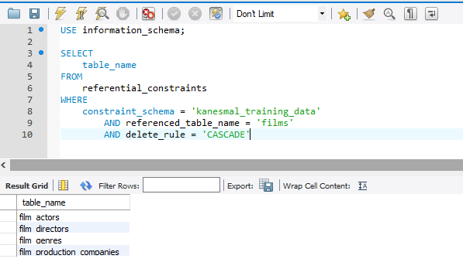

Finally, utilising the following two statements I can see how many films have the ‘cancelled’ status and ensure that only that number of films have been removed from the database:

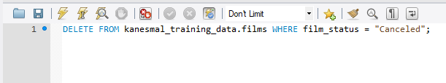



## Problems encountered

* Cannot delete films that have references to other tables
* Cascade delete function is confusing at first

## Tools used

* PyCharm
* MySQL Workbench
* Google Chrome
* GitHub

## References

* <https://stackoverflow.com/questions/9220821/how-to-set-up-cascading-deletes-in-mysql-workbench>
* <http://www.mysqltutorial.org/mysql-on-delete-cascade/>

## Keywords

CASCADE DELETE

# Week 22 (05/03/2018 – 11/03/2018)

## Objectives

* Search improvements

## Description

This week I focused on improving the searching experience for users. This primarily involved the actual data that was being displayed to the user within the search results, but also included improvements to the styling and to the ordering of the results.

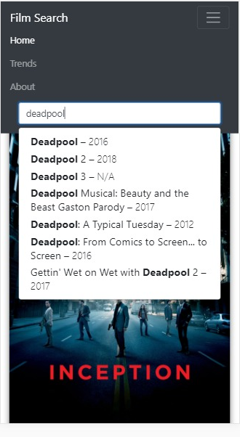The end result was a transformation from the following screenshot:

To the screenshot below:

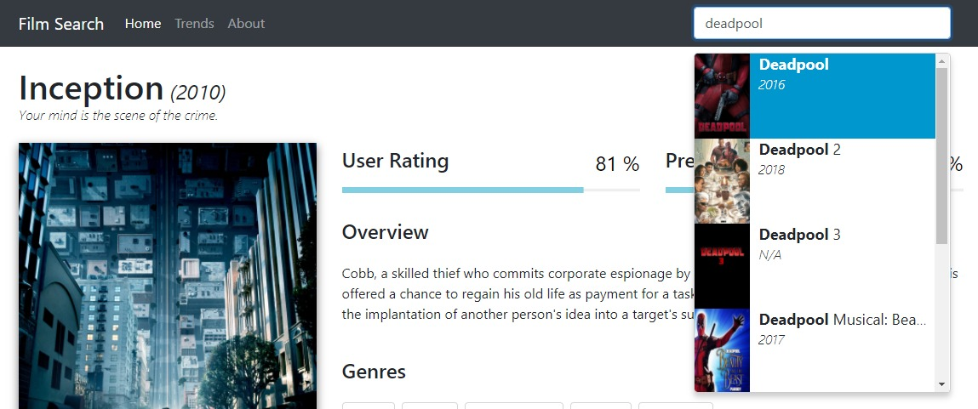

With the final design looking like this:

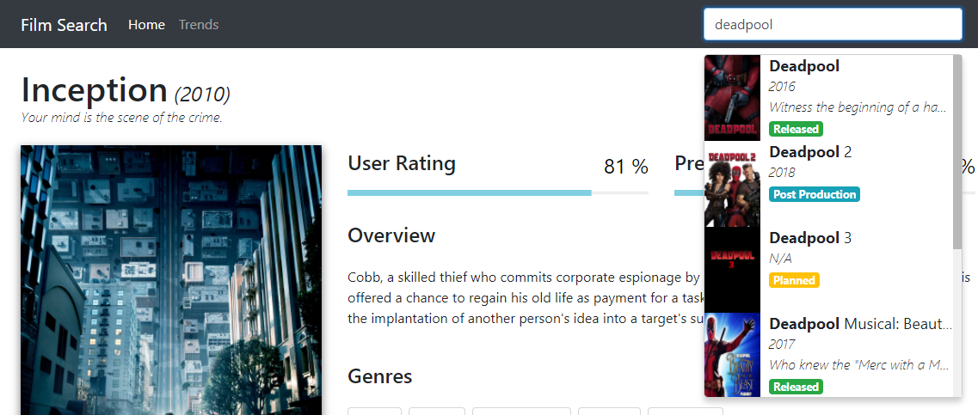

Essentially, I decided to include more information in the search results which would aid the user in finding exactly the right film that they were searching for. This included, the release year, film tagline (where the overflow was set to *ellipsis* to avoid any positioning errors) and the film status.

## Problems encountered

* Styling
* Positioning
* Ordering a jsonpickle formatted list

## Tools used

* PyCharm
* MySQL Workbench
* Google Chrome
* GitHub

## References

* <https://stackoverflow.com/questions/403421/how-to-sort-a-list-of-objects-based-on-an-attribute-of-the-objects>

## Keywords

N/A

# Week 23 (12/03/2018 – 18/03/2018)

## Objectives

* Implementing a regression algorithm
* Looking at the results/accuracy

## Description

This week (and some of last week) was aimed at implementing the regression algorithm. I started by building up a script that would be responsible for handling the acquisition of the data from the database, pre-processing the data so that it was in the correct format and training the model so that predictions could be made.

I first had to decide on the right estimator for the job. I ended up selecting a decision tree learner regression model as it is best suited toward projects that have a lot of samples and needs a quantity value to be predicted as opposed to a class or categorical value. A big advantage of decision trees is that there are able to handle features that are both numerical and categorical, which is something that my dataset has.

The DecisionTreeRegressor class function takes in two parameters, a list of X values which are 2-D lists and a list of y values (***X = [[0, 0], [2, 2]], y = [0.5, 2.5]***), so before I could fit the data to the model the data had to first be pre-processed.

The features that had been selected, influenced by the results of the questionnaire, were as follows:

* genres
* budget
* runtime
* trailer_view_count
* trailer_like_count
* trailer_dislike_count
* user_rating

Due to the method of acquiring the data, I had already ensured that I did not store any duplicate entries into the database. However, I did have a lot of NULL values so these had to be dealt with. When using machine learning algorithms certain algorithms will be able to handle NULL values automatically, but unfortunately the decision tree learner is not one of them. So, this left me with three options:

1. Remove the rows with NULL data
2. Ignore the rows with NULL data
3. Impute the NULL values

I opted for option 3, as this allowed me to keep all of the other data intact and allow it to still be used for the training of the model. Essentially, imputation replaces all NULL values in the dataset with an arbitrary value that isn’t used anywhere else. So, I decided on the value ***-1***, as none of my values in my dataset are negative so the model would be able to distinguish this value from the rest and understand that it effectively represents a NULL value.

Next, I had to encode the genres because each film can have multiple genres attached to it, but the input requires singular feature attributes. So, to mitigate this problem I utilised a technique that I had learned in one of my data mining lectures whereby any features similar to genres are essentially encoded using *one-hot encoding*, which creates a category for every genre there is (all 37 genres) and then represents whether or not a film has that genre by setting the value to 0 or 1 (binary representation).

So the following table, which represents all of the genres for three separate films:

|  |  |  |  |
| --- | --- | --- | --- |
| **Inception** | **Interstellar** | **Iron Man** | **…** |
| Action | Adventure | Action | … |
| Thriller | Drama | Science Fiction | … |
| Science Fiction | Science Fiction | Adventure | … |
| Mystery |  |  | … |
| Adventure |  |  | … |

Would be converted into the following format:

|  |  |  |  |  |  |
| --- | --- | --- | --- | --- | --- |
|  | **genre_Action** | **genre_Adventure** | **genre_Drama** | **genre_Mystery** | **genre_Science_Fiction** |
| **Inception** | 1 | 1 | 0 | 1 | 1 |
| **Interstellar** | 0 | 1 | 1 | 0 | 1 |
| **Iron Man** | 1 | 1 | 0 | 0 | 1 |
| **…** | … | … | … | … | … |

Lastly, I had to ensure that I now reduced down my entire formatted feature set to just two dimensions. To accomplish this I used a technique called PCA (Principal Component Analysis), which reduces the data down to it’s basic components and strips away any unnecessary parts not required by the model.

So, the following data (genres excluded for visual purposes only):

|  |  |  |  |  |  |
| --- | --- | --- | --- | --- | --- |
| **Budget** | **Runtime** | **trailer_view_count** | **trailer_like_count** | **trailer_dislike_count** | **user_rating** |
| 4000000 | 98 | 407034 | 496 | 28 | 6.5 |
| 0 | 110 | 26589 | 71 | 5 | 6.4 |
| 42000 | 80 | 17347 | 36 | 2 | 6.4 |
| 11000000 | 121 | 696398 | 3296 | 82 | 8.1 |
| … | … | … | … | … | … |

Becomes this, after the target column has been stripped off:

**+**

|  |  |
| --- | --- |
| **principal_component_1** | **principal_component_2** |
| -0.900681 | 1.032057 |
| -1.143017 | -0.124958 |
| 1.385353 | 0.337848 |
| -1.506521 | 0.106445 |
| … | … |

|  |
| --- |
| **user_rating** |
| 6.5 |
| 6.4 |
| 6.4 |
| 8.1 |
| … |

So, now all of the values have been reduced down revealing the main dimensions of variation and the user ratings can be appended back on. Now the data is ready to be fitted to the model for training purposes.

Using the DecisionTreeRegressor class as part of the scikit-learn library, the inputs are taken in and the regressor begins to build the tree.

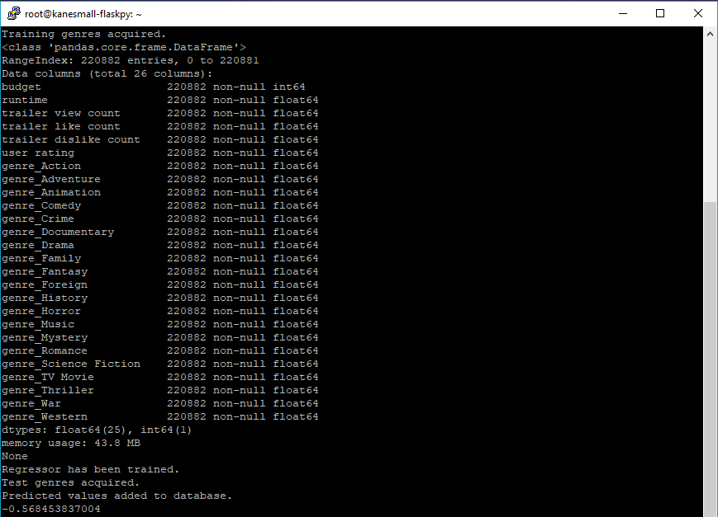

The screenshot above is the output from the console, which shows what is happening at each stage, until the regressor has been trained and the prediction values are set in the database. It ends with the explained variance value being printed to the console.

Finally, we have the results. I trained the model three separate times using different training data based on certain parameters. Here are the results:

* Explained variance: 0.1535
  + All training data
  + 4-5 distinct prediction results
* Explained variance: 0.0512
  + All training data, without NULL values
  + 4-5 distinct prediction results
* Explained variance: -0.5685
  + Max tree depth undefined
  + A lot more variation in predicted values

A negative explained variance as can be seen from the final result and is from the model still be used today, can mean that the data being used is imbalanced. This is where the data being trained is extremely different from the data being tested on and is actually the case with the data acquired, as a lot of the test data is NULL. Sometimes negative explained variances can occur even when there is a positive outcome with the values being predicted, which could be the case here, but it is hard to tell.

Using an additional regression metric, MAE (Mean Absolute Error), can tell us whether we have overestimated or underestimated the predictions values based on the actual values. So, if we were to plot the results on a graph, a straight line would be drawn where X=Y and the closer to this line the values are the more accurate the model is. The MAE essentially tells us what the average spread of the errors is, which is this case indicates a positive value that represents an overestimation of the prediction values in general.

## Problems encountered

* Explained variance is negative
* Could not implement a technique to utilise the actors as a feature with the time provided
* Could not compare other models to see determine which is the most accurate fit for my dataset

## Tools used

* PyCharm
* MySQL Workbench
* Google Chrome
* GitHub

## References

* <http://scikit-learn.org/stable/modules/generated/sklearn.tree.DecisionTreeClassifier.html>
* <http://scikit-learn.org/stable/modules/tree.html#tree>
* <http://scikit-learn.org/stable/tutorial/machine_learning_map/index.html>
* <http://scikit-learn.org/stable/modules/model_evaluation.html#regression-metrics>
* <http://scikit-learn.org/stable/modules/generated/sklearn.metrics.mean_absolute_error.html>

## Keywords

Decision tree classifier, one-hot encoding, PCA, regression, MAE

# Week 24 (19/03/2018 – 25/03/2018)

## Objectives

* Focus on building trend graphs

## Description

This week I focused on building the trend graphs that would be displayed on the **/trends** page. I utilised a library that I had used in the past called *chart.js*, which is an extremely powerful charting and graphing library with a lot of configurable options available.

I started by again, creating additional API routes and classes within my Python Flask script that would be responsible for retrieving the relevant/required data from the database, formatting it with the class, translating it to JSON and then displaying the data to the front-end for the user to see.

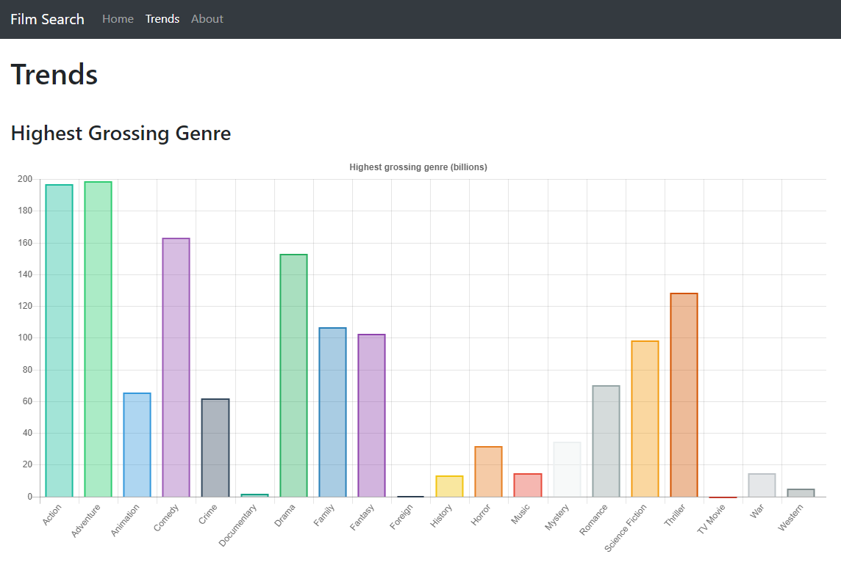

The end result is the bar chart illustrated above.

## Problems encountered

The main problem encountered was the load times of the chart elements. This was to the best of my knowledge, a result of the API having to run the SQL statements on the database which took a long time considering the amount of data it had to query. To mitigate this issue, I essentially created two separate routes for the trend graphs. The first ***/get_trends/<int:trend_id>*** would essentially acquire the data from the database by running the required SQL statements and store the JSON formatted results into a .json file on the server (ensuring to overwrite any existing files). The second ***/show_trends/<int:trend_id>*** would locate the relevant file based on the ***trend_id*** that had been passed and load the data directly from the json file without having to perform any expensive SQL operations.

## Tools used

* PyCharm
* MySQL Workbench
* Google Chrome
* GitHub

## References

* <http://www.chartjs.org/samples/latest/>

## Keywords

N/A

# Week 25 (26/03/2018 – 01/04/2018)

## Objectives

* Move existing infrastructure over to a DigitalOcean Droplet

## Description

I decided to move all of my existing Flask application infrastructure and database over to a DigitalOcean droplet. I discovered that as a student through GitHub’s student developer pack I was able to receive $50 worth of credits to use on DigitalOcean and I was also able to acquire a free domain for a year with Namecheap. This enabled me to move my application to a much more powerful, stable and reliable platform. This would also provide a much more maintainable solution for the future, as having my raspberry pi on consistently is not the most viable solution especially since power cuts can occur and I do not have a redundant backup power supply such as a UPS.

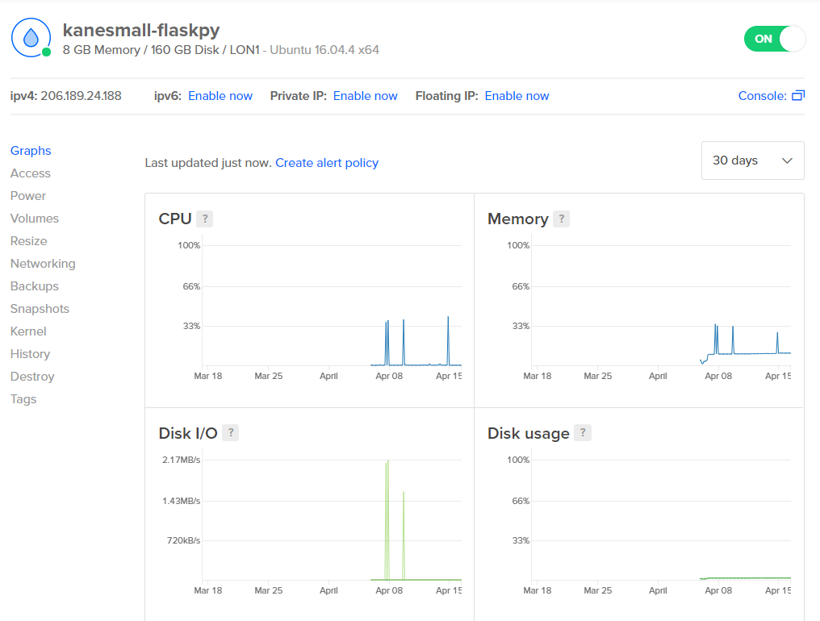

In order to connect to the server I utilised two applications, Filezilla and PuTTY. Filezilla is an FTP (File Transfer Protocol) client and PuTTY is a terminal emulator that can communicate to the server via SSH (Secure Shell). Filezilla is used to allow me to update the copies of files stored on the server with files that have been updated on my local machine. SSH allows me to run Python scripts on the server, configure the Nginx web server, configure the Flask application and also configure the database.

## Problems encountered

Setting up an Apache web server proved difficult, but in the end was resolved by instead setting up and configuring an Nginx web server on the droplet following the tutorial/guide that DigitalOcean provides.

## Tools used

* PyCharm
* MySQL Workbench
* Google Chrome
* GitHub
* Filezilla
* PuTTY

## References

* <https://education.github.com/pack>
* <https://www.digitalocean.com/community/tutorials/how-to-serve-flask-applications-with-gunicorn-and-nginx-on-ubuntu-16-04>
* <https://filezilla-project.org/>
* <https://www.chiark.greenend.org.uk/~sgtatham/putty/latest.html>

## Keywords

DigitalOcean Droplet, UPS, SSH, FTP, Nginx

# Week 26 (02/04/2018 – 08/04/2018)

## Objectives

* Improving design

## Description

This week I primarily focused on improving my overall front-end design. This revolved around making the information on the page a lot more user-friendly and laid out in a format that was concise and flowed in a more design and user-friendly manner.

This was mainly a matter of working with the CSS to style the elements on the page, but also involved the use of external libraries such as *progressbar.js*, which provides a sense of a more polished and professional-looking application.

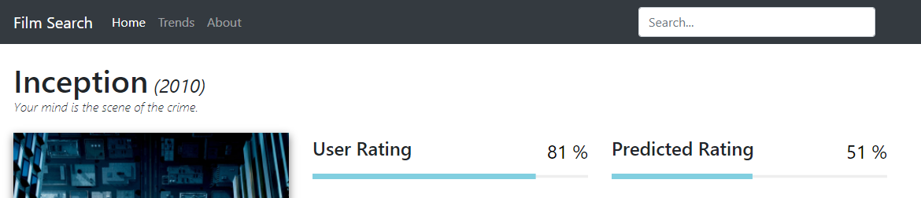

Both the user and prediction ratings utilised the progress bar library, which also included animations whenever the data is updated.

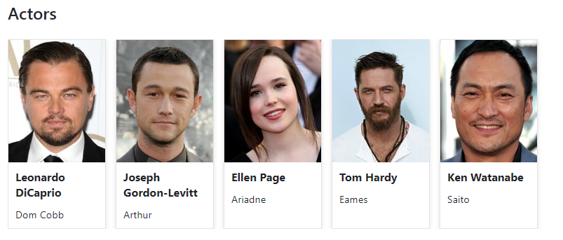

As depicted above, I also worked on displaying the top 5 actors in a succinct manner, ensuring that the actor pictures were easy to see and not blurry and that the names and characters were also readily available to the viewer, but were also separated.

Ultimately, my application ended up transitioning away from this screenshot below:



To this screenshot below:

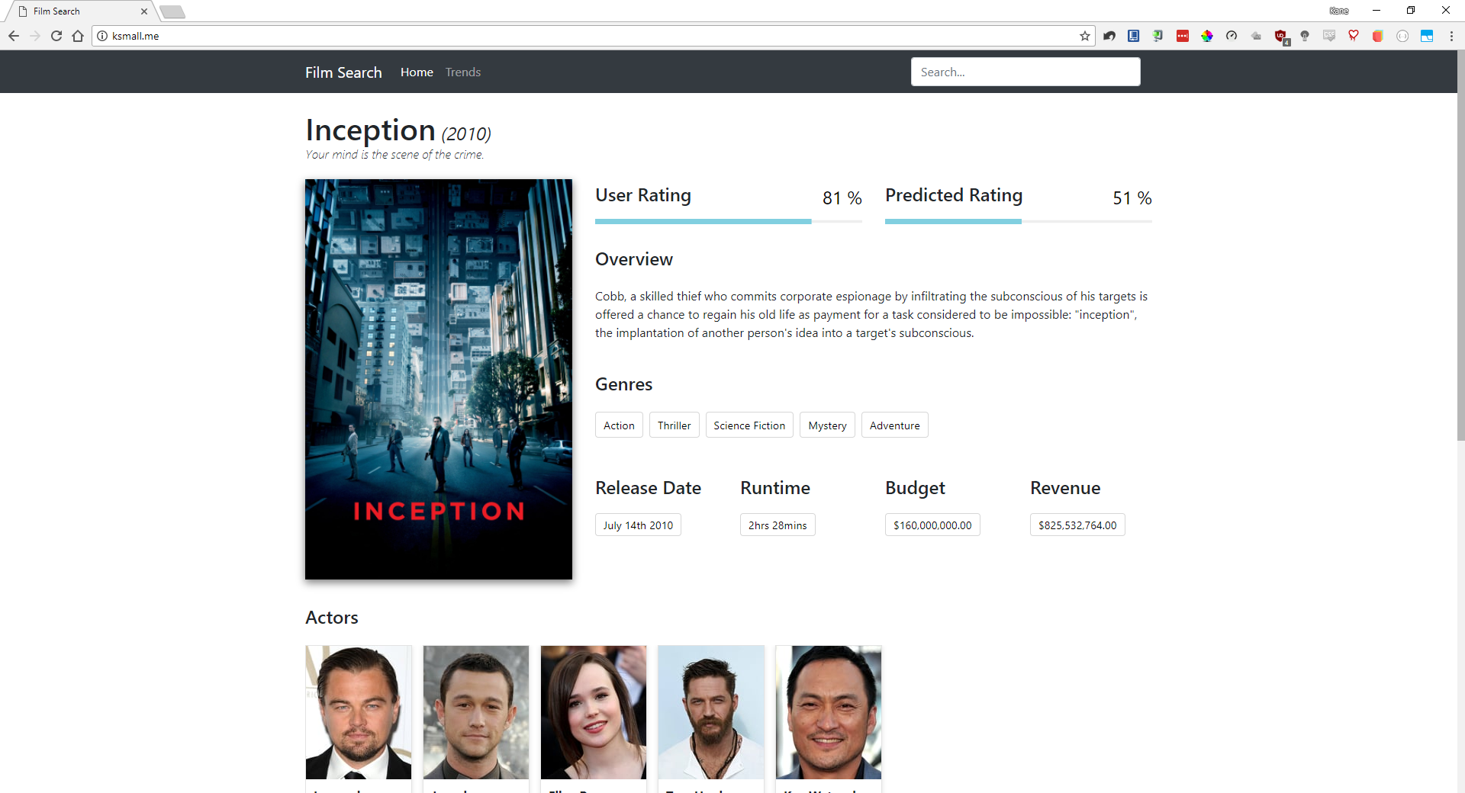

## Problems encountered

* Formatting the progress bars was extremely difficult, especially when it came to positioning the dynamic percentage value.
* Styling can sometimes overlap, so ensuring that each element has a unique class and/or id value is essential.

## Tools used

* PyCharm
* MySQL Workbench
* Google Chrome
* GitHub
* DigitalOcean
* PuTTY
* Filezilla

## References

* <https://kimmobrunfeldt.github.io/progressbar.js/>

## Keywords

N/A

# Week 27 (09/04/2018 – 15/04/2018)

## Objectives

* Create PowerPoint presentation

## Description

This week has been focused on creating a presentation for the presentation/demonstration next week. On Tuesday I had a practice presentation with my supervisor, which helped me to receive some extremely valuable feedback. I recorded all feedback using a voice recorder so that I could play it back when I got home, as I knew I would forget what had been said during the session otherwise.

I managed, to my surprise, to speak for 25 minutes during the practice session, which was obviously too long but in my opinion, it is easier to cut down time than to have to think of more to say. Using the 50 minutes of feedback that I received from my supervisor I wrote down all of the parts of the presentation that either needed removing or amending and then carried out these changes.

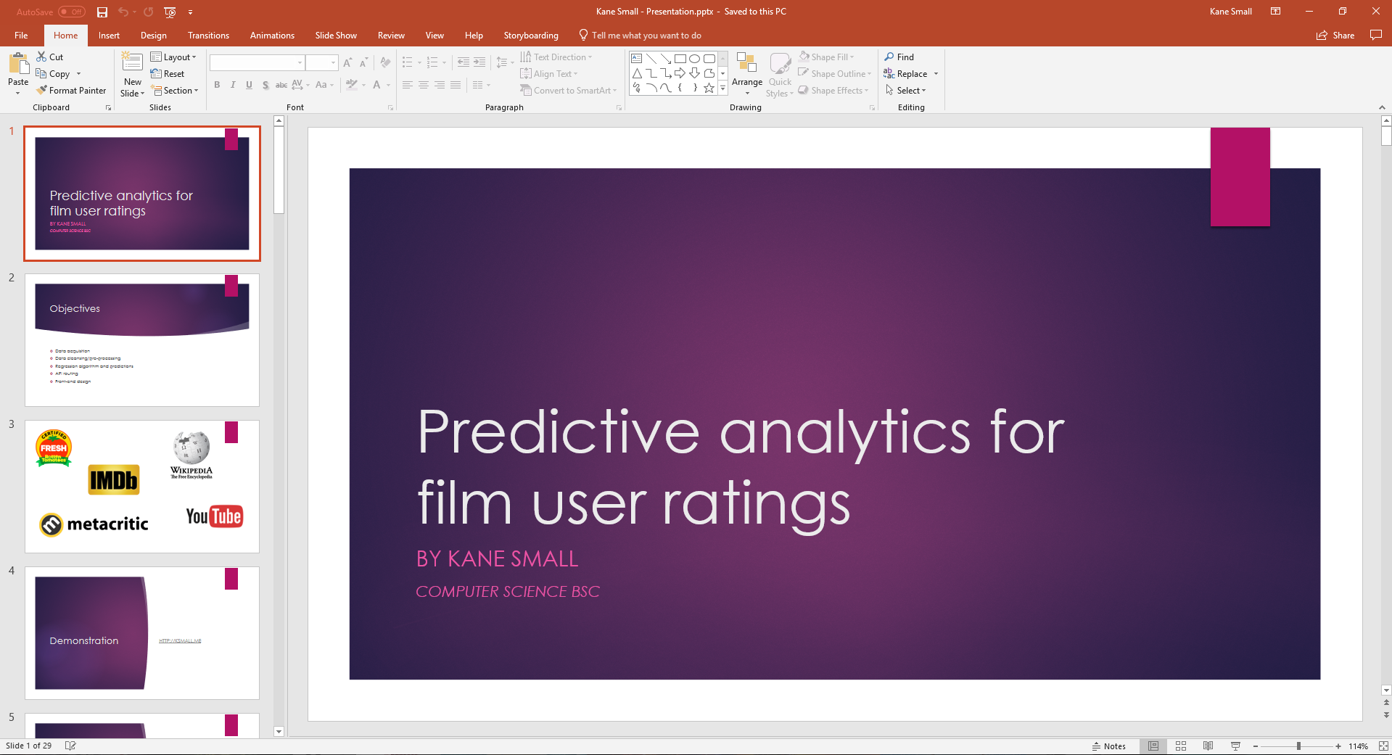

## Problems encountered

* Needed to cutdown my presentation
* Went into too much detail regarding code and/or functions or classes that had been created

## Tools used

* Google Chrome
* Microsoft PowerPoint

## References

* N/A

## Keywords

N/A

# Week 28 (16/04/2018 – 20/04/2018)

## Objectives

* Giving my presentation
* Finalising the report

## Description

This week has primarily been focused on finalising the report, but on Tuesday I also had to give my presentation to a panel of 4 people.

## Problems encountered

The stress has been extremely overwhelming this year, especially in the last few weeks and it has been causing me to shutdown due to my disabilities.

## Tools used

* Google Chrome
* Microsoft Word
* Microsoft PowerPoint

## References

* N/A

## Keywords

N/A